44-560 ADVANCED TOPICS IN DB SYSTEMS  
Assignment – 04

Name : Vasanth Sai Aitha

SID : S571903

1. Creating Tables

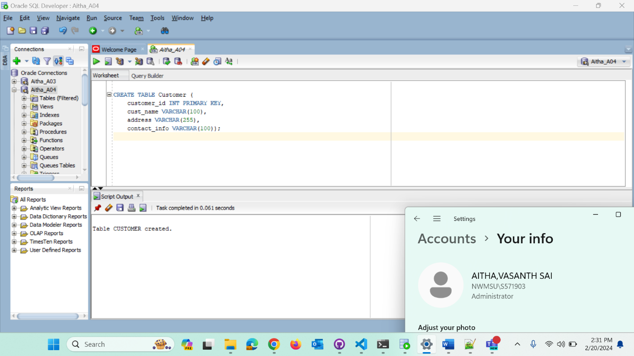

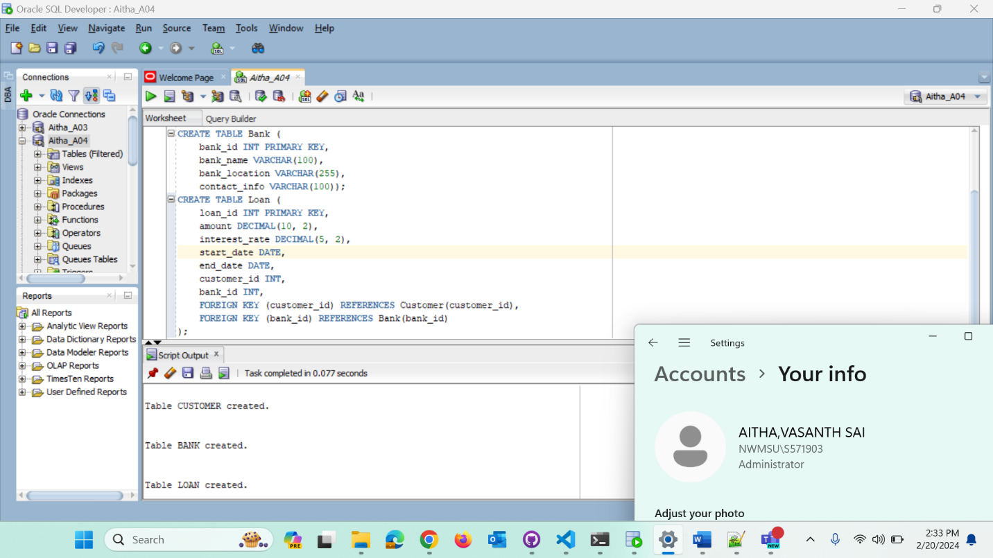

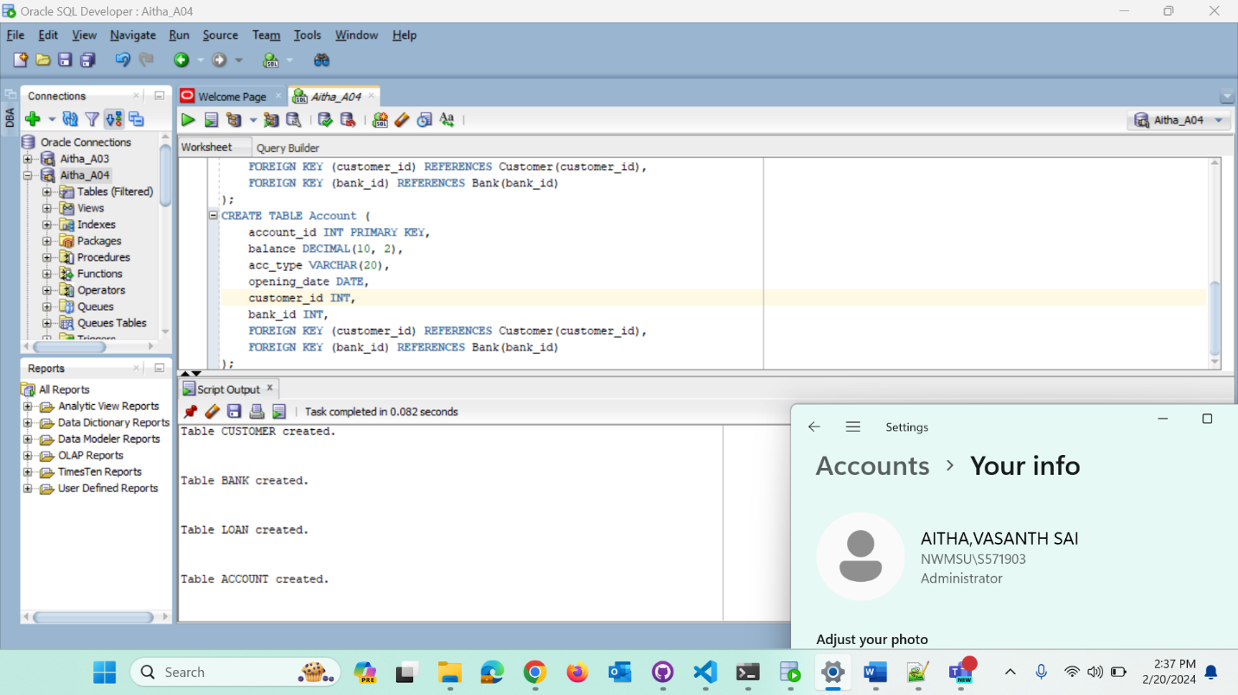

2. Data insertion

1Write a query to retrieve the total account balance, total loan amount, and number of  
customers from their respective tables without specifying entity types

Write a query to identify customers who simultaneously hold a savings account and a loan  
exceeding $10,000. Provide the SQL query with appropriate conditions to filter accounts  
and loans accordingly.

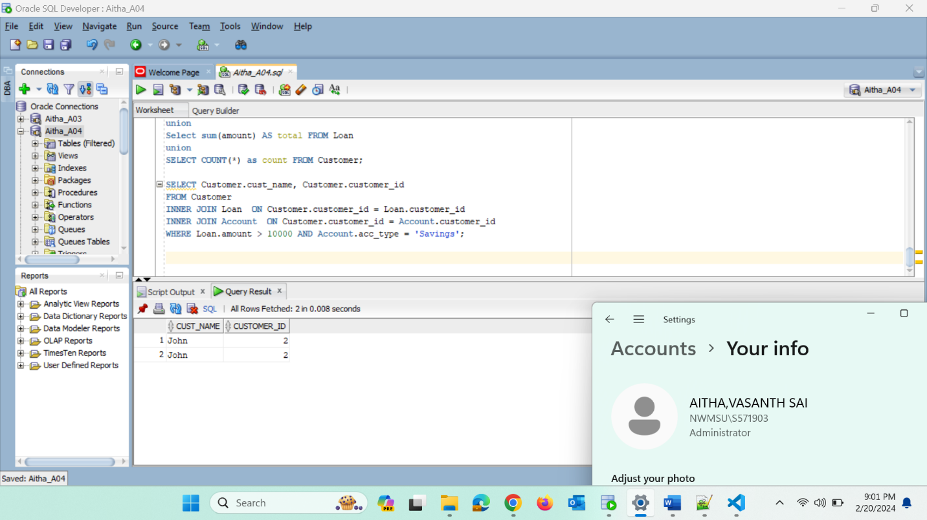

Write a query to find the account IDs that are present in the 'Account' table but are not  
associated with any customer in the 'Customer' table. Provide the account IDs.

Write a query to retrieve the account ID, balance, account type, opening date, customer  
name, and bank name for all accounts, including those without associated customers or

Write a query to fetch customer details, account information, and corresponding bank  
details for accounts with balances exceeding $5000. Ensure all account and bank records  
are included, even if there are no corresponding customer records.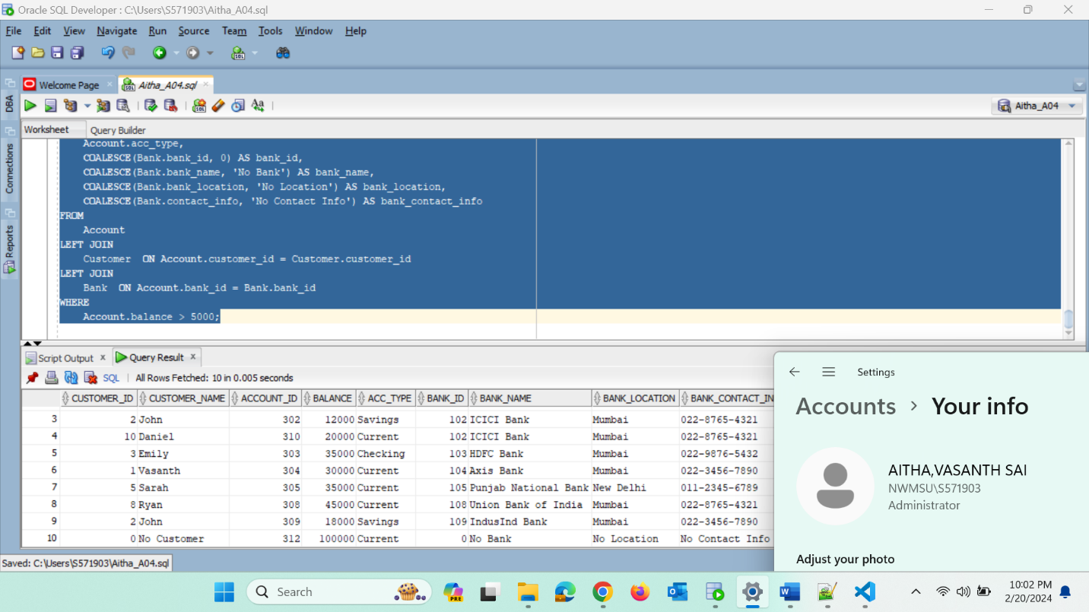

Write a query to fetch all accounts and their associated customers, including those accounts  
without customers, filtering only for accounts of type 'Savings'.

Write a query to retrieve the names of customers who have taken loans with an interest  
rate exceeding 5.0%.

Write a query to identify customers with active checking accounts who currently hold  
ongoing loans.

Write a query to list all banks and the loans they have issued, including banks without any  
loans.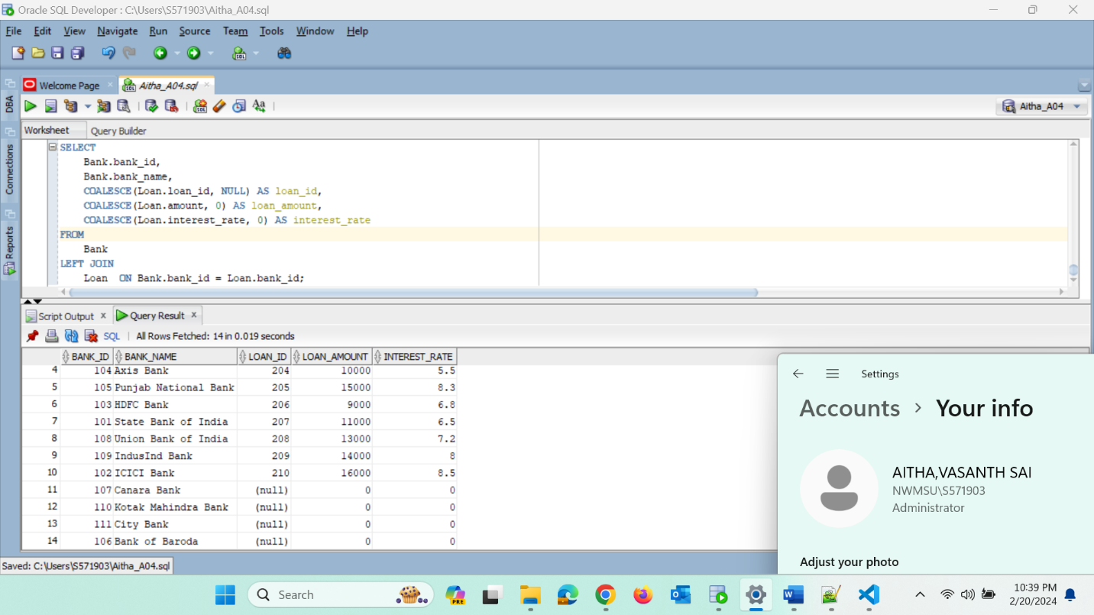

Create a sequence named 'order_id_seq' with the following properties: it should start at  
1001, increment by 1 for each new value, have a maximum value of 999999999, and not  
cycle back to the start. Ensure that no caching is applied during the sequence generation  
process.